Practical exercise – Soccer SQL Questions (Microsoft SQL Server )
Question 1.
View the first 100 rows of the dataset to understand its structure.
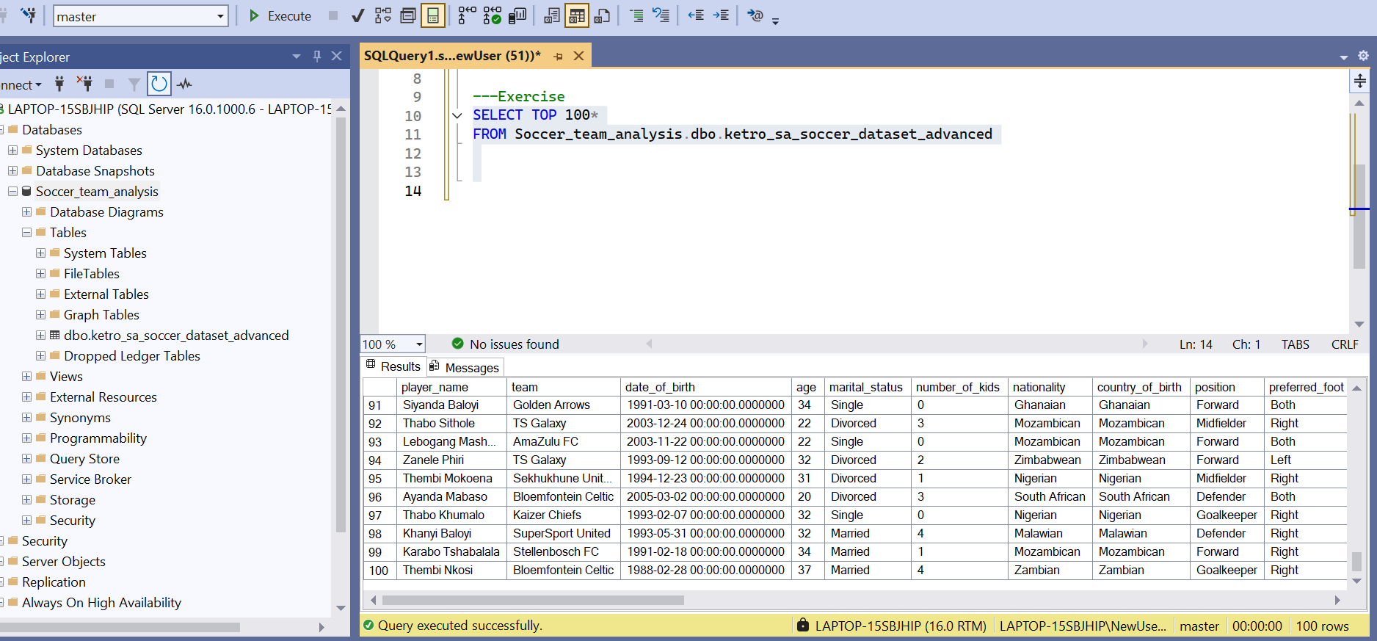

QUESTION 2
Count the total number of players in the dataset.
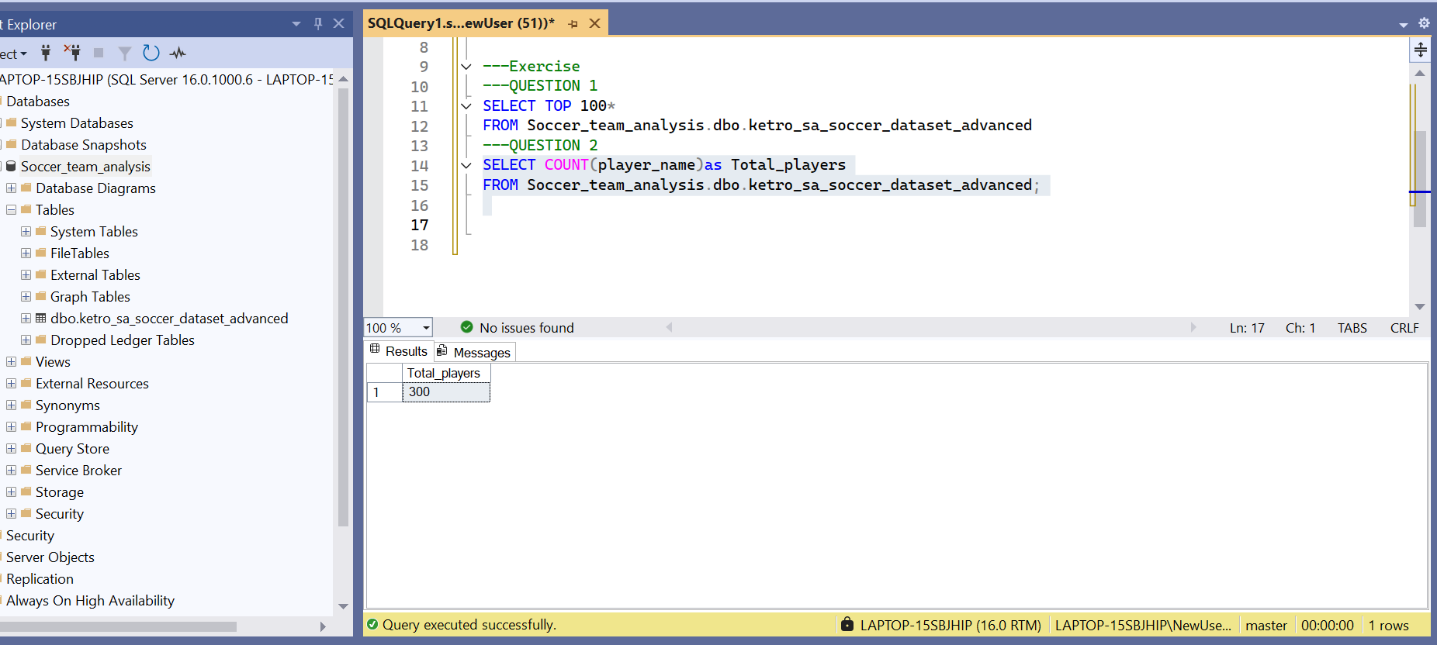

Question 3
List all unique teams in the league.
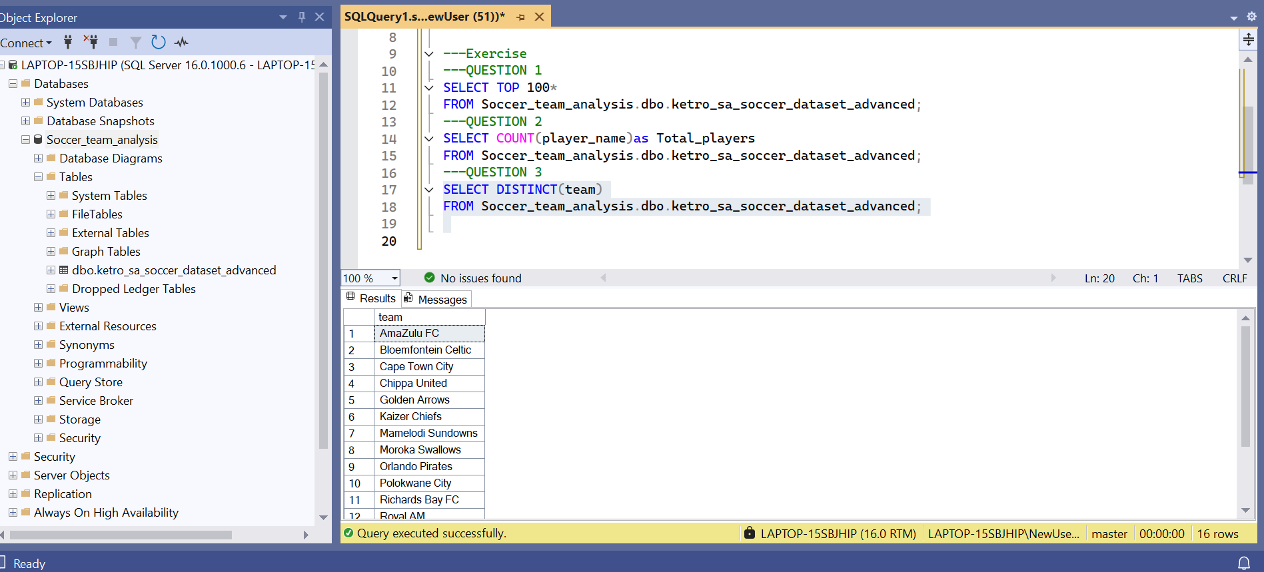
Question 4
Count how many players are in each team.
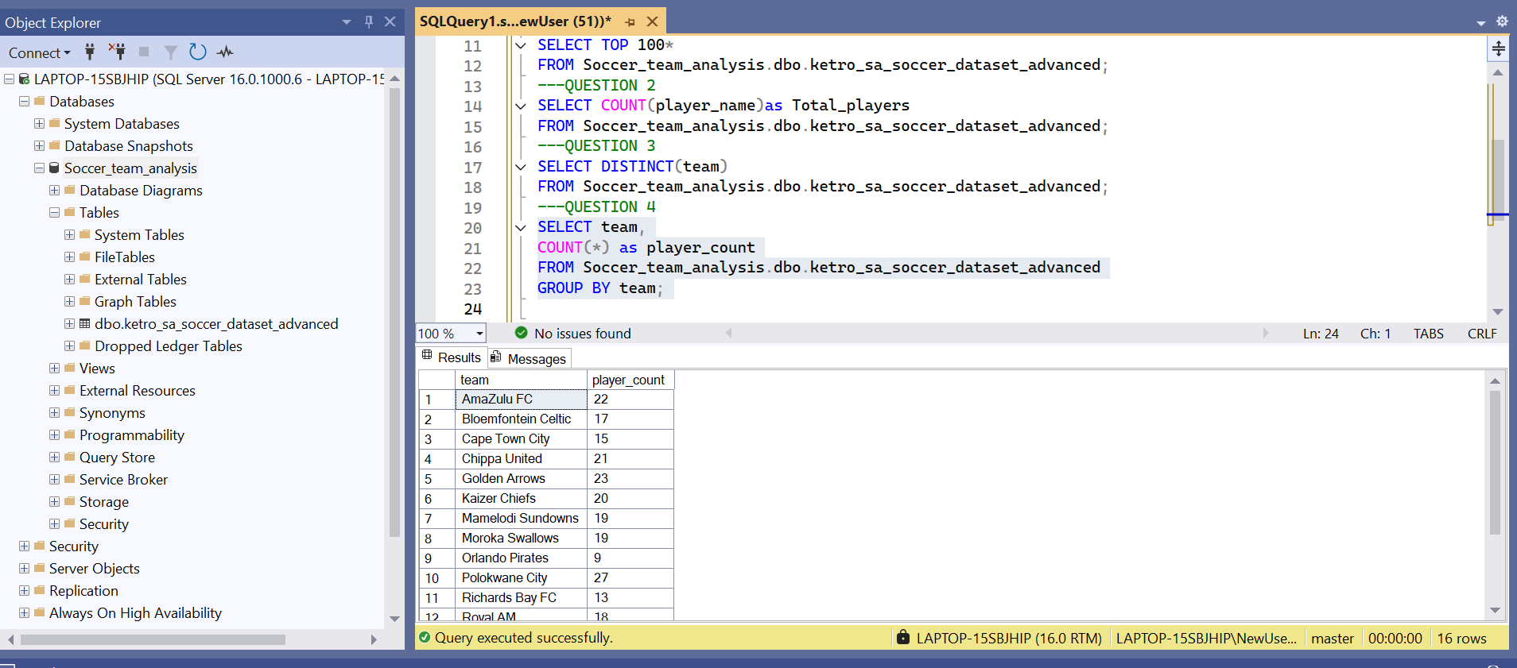
Question 5
Identify the top 10 players with the most goals.
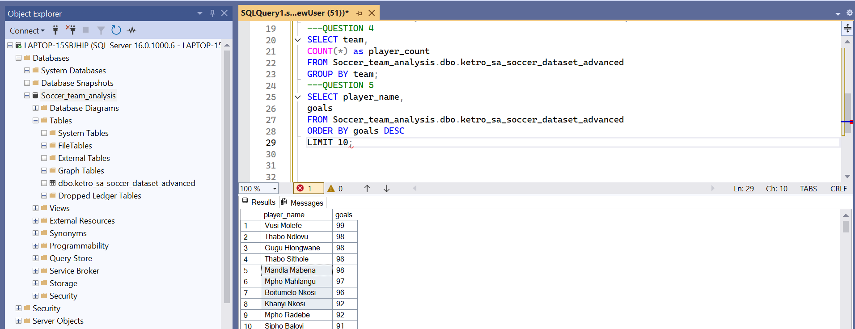
Question 6
Find the average salary for players in each team.
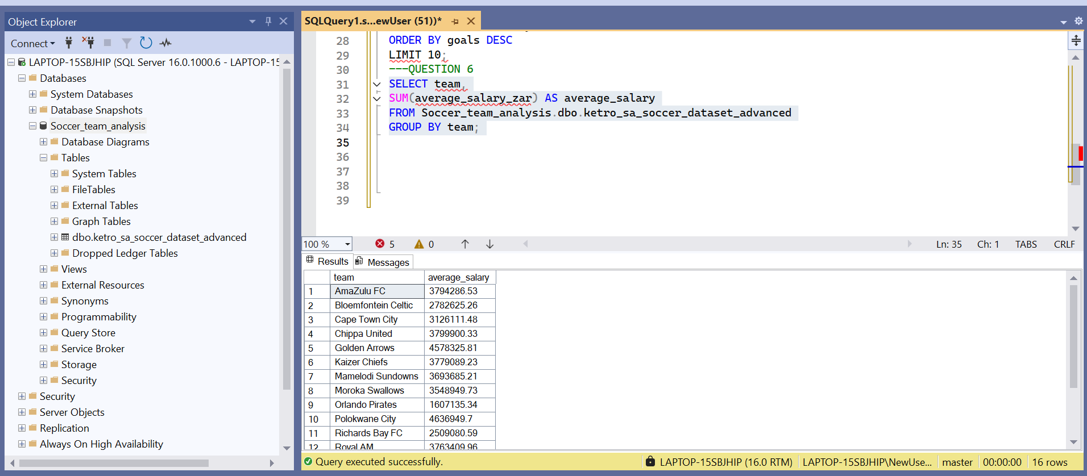
Question 7
Retrieve the top 10 players with the highest market value.
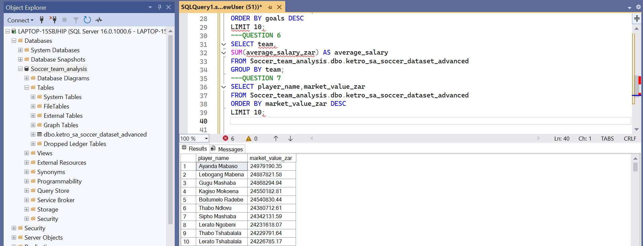
Question 8
Calculate the average passing accuracy for each position.
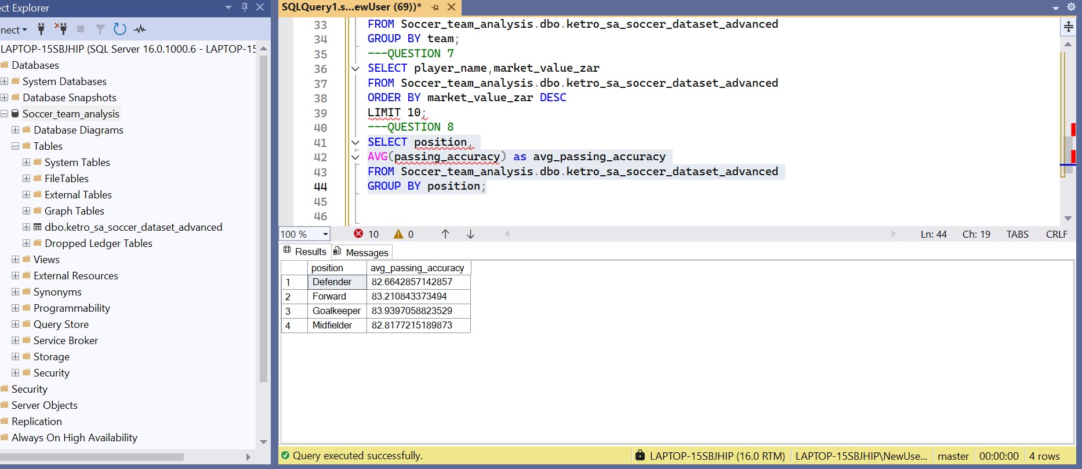
Question 9
Compare shot accuracy with goals to find correlations.
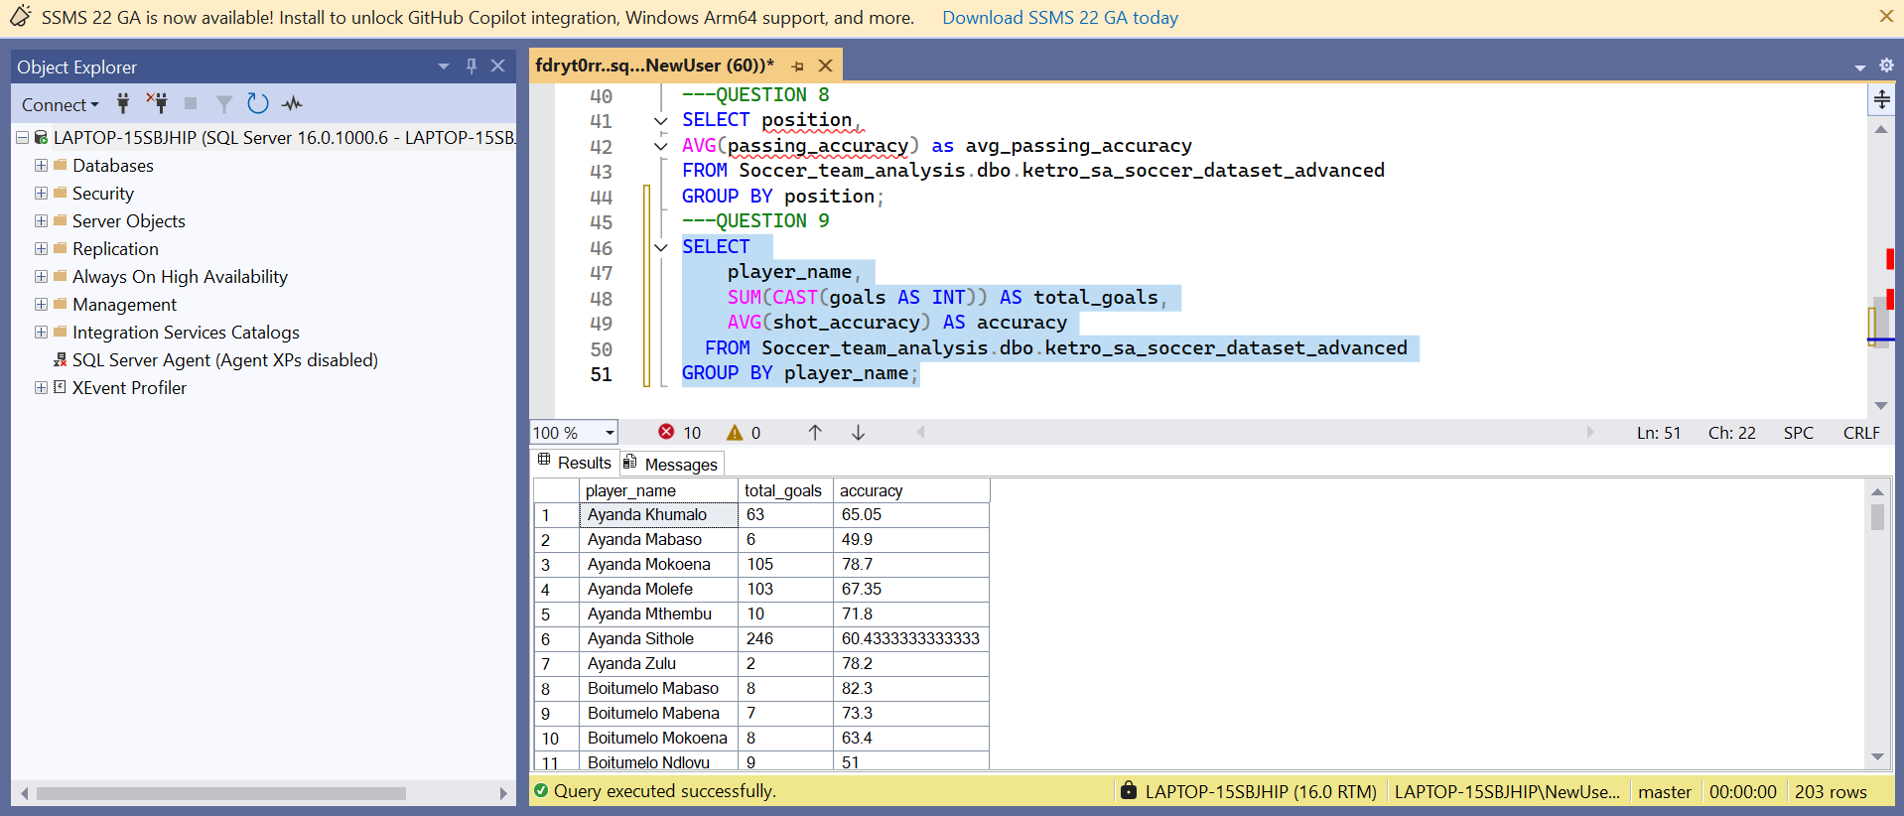
Question 10
Compute total goals and assists for each team
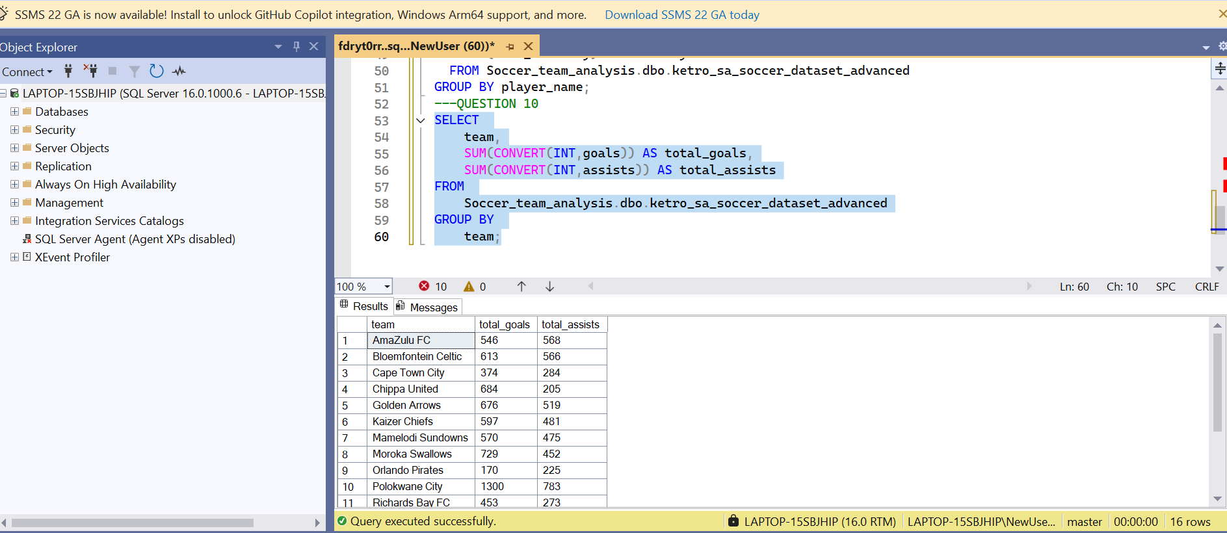
Question 11
Count players by their marital status.
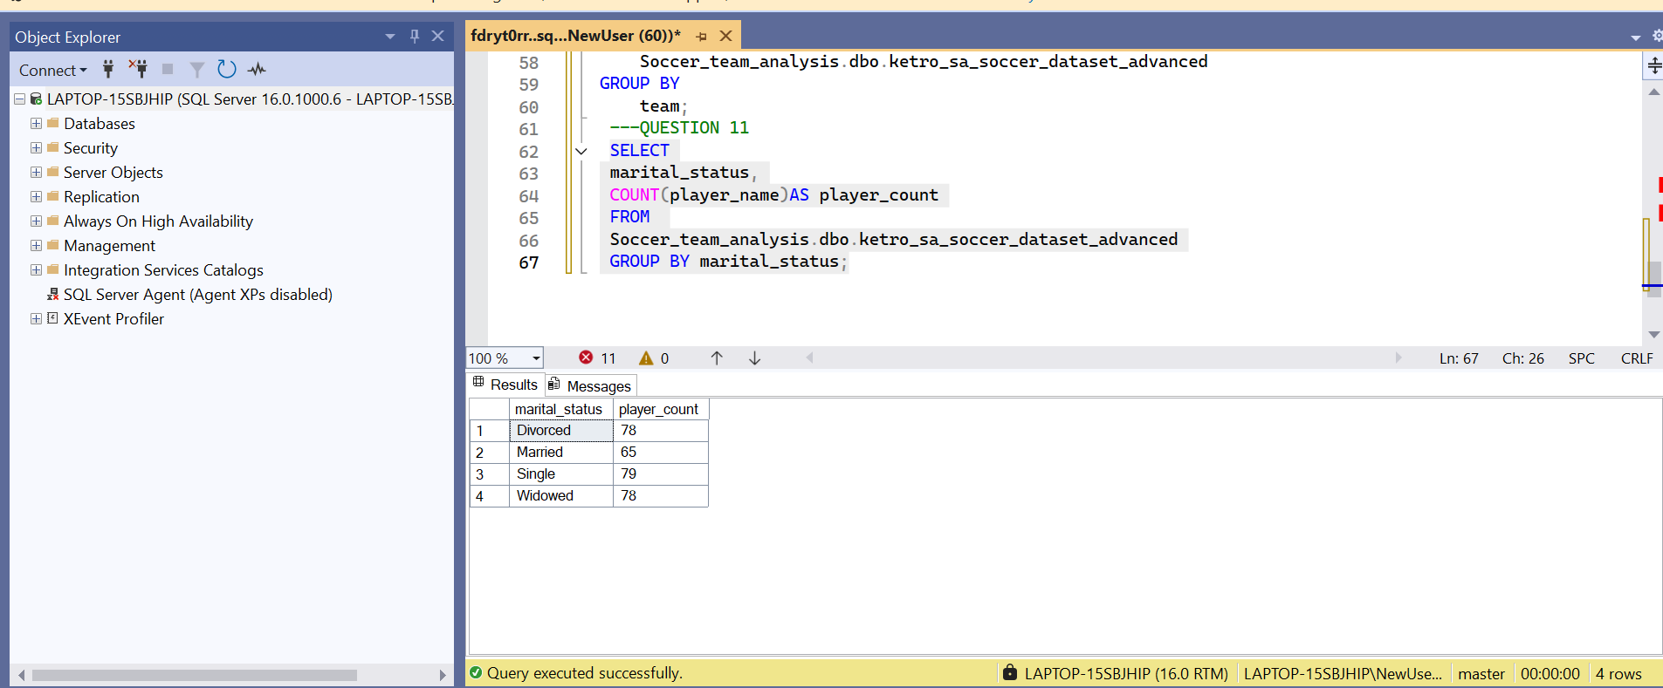
Question 12
Count players by nationality.
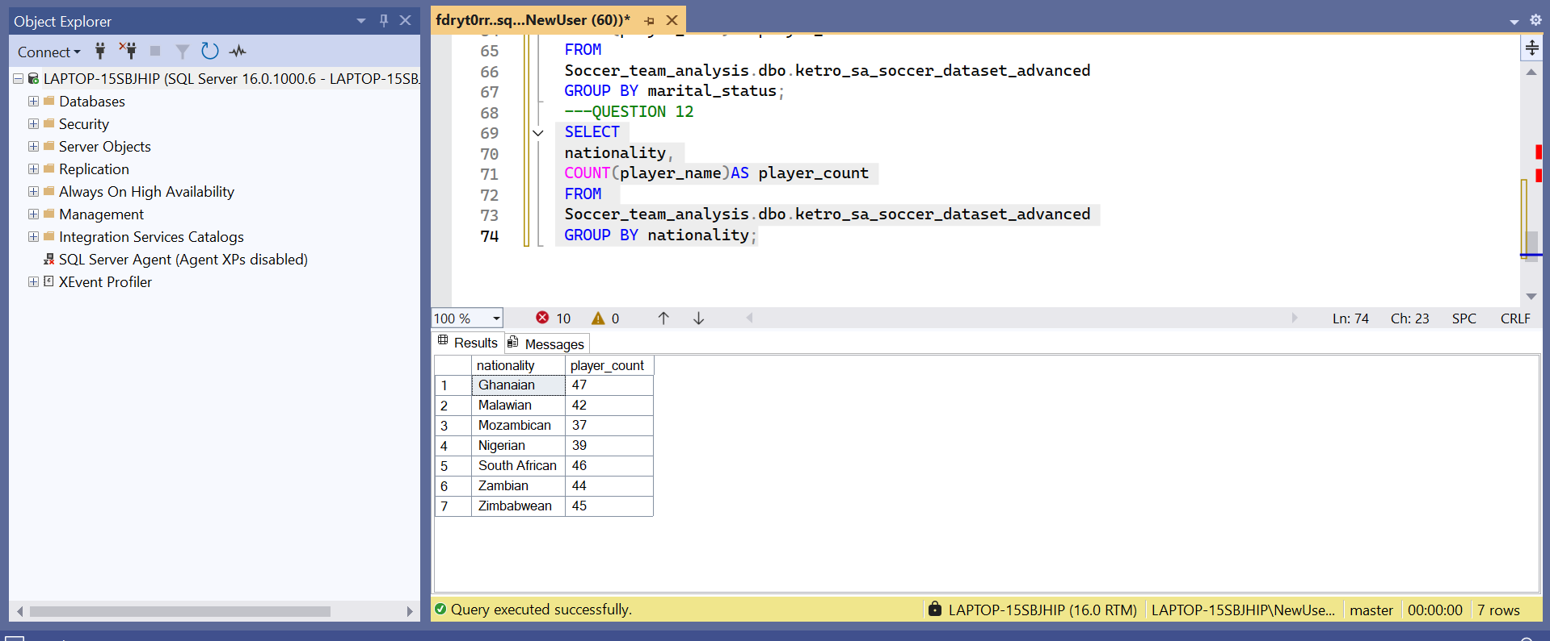
Question 13
Find average market value grouped by nationality.
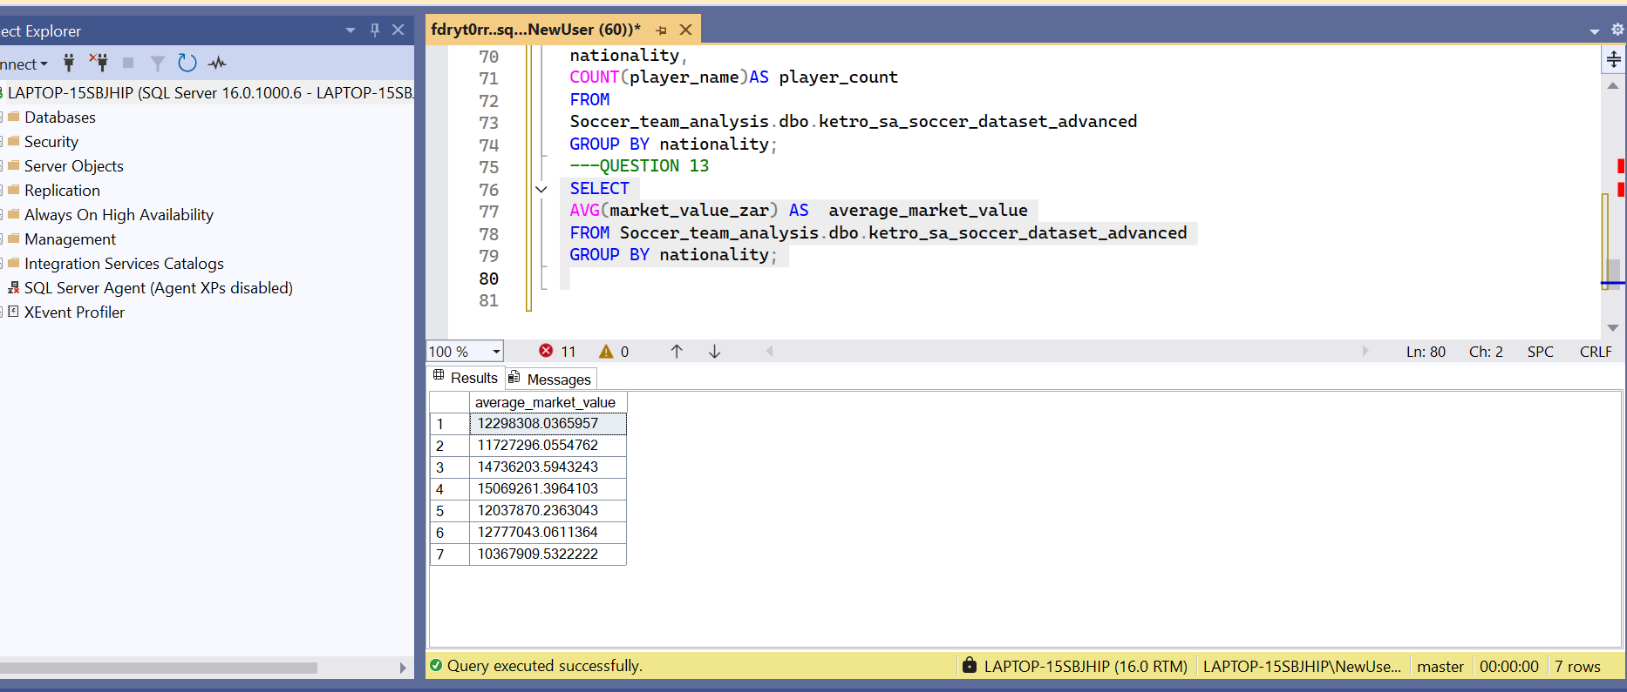
Question 14
Determine how many player contracts end in each year.
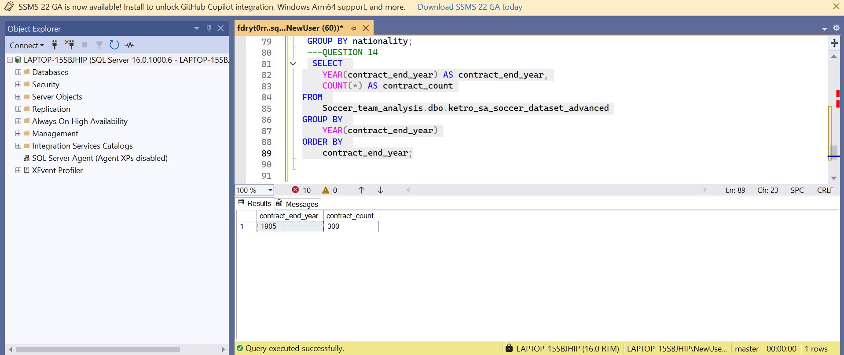
Question 15
Identify players whose contracts end next year.
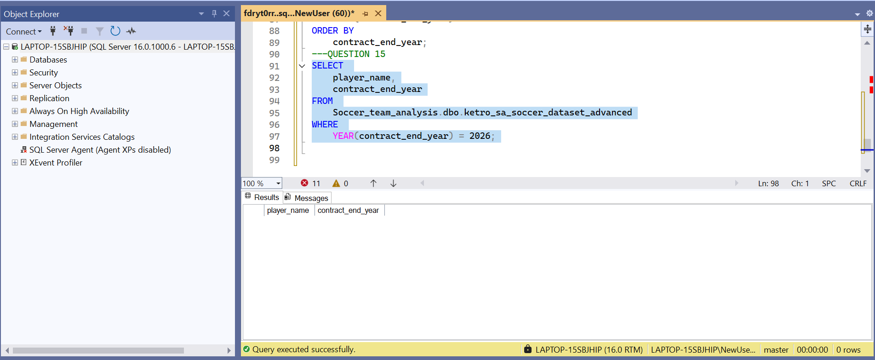
Question 16
Summarize the number of players by injury status.
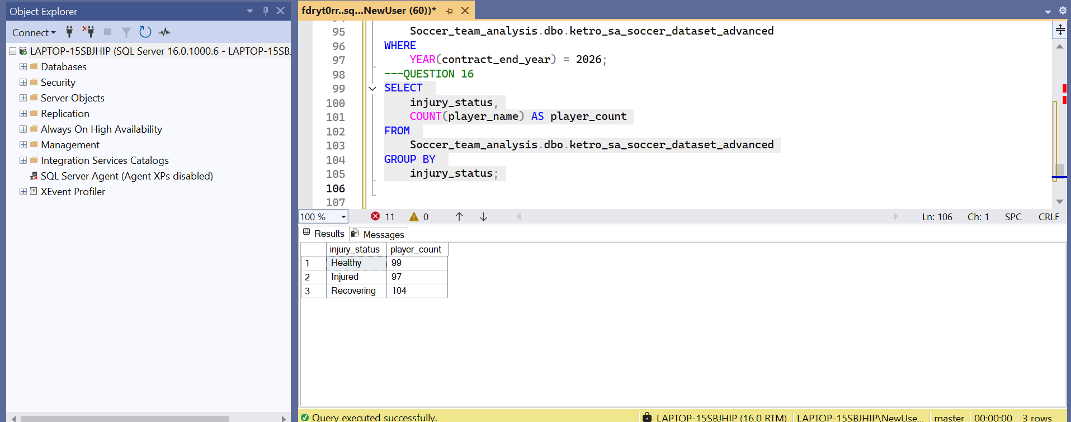
Question 17
Calculate goals per match ratio for each player.
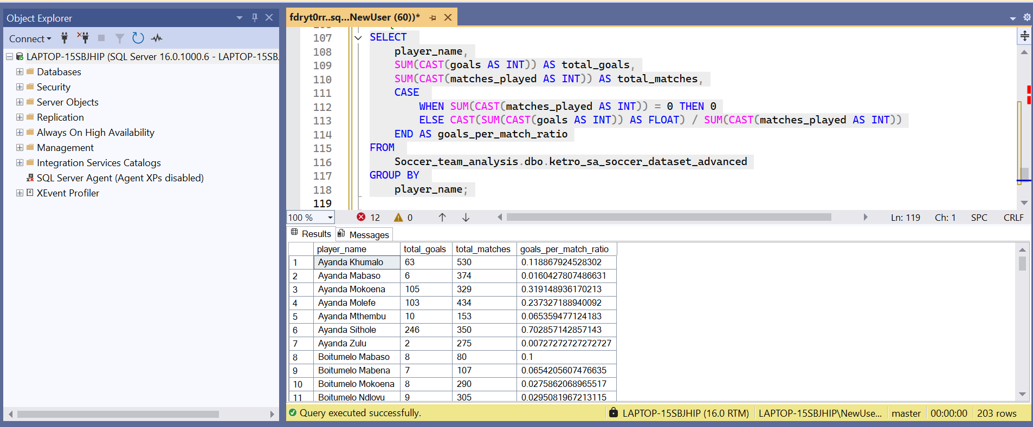
Question 18
Count how many players are managed by each agent.
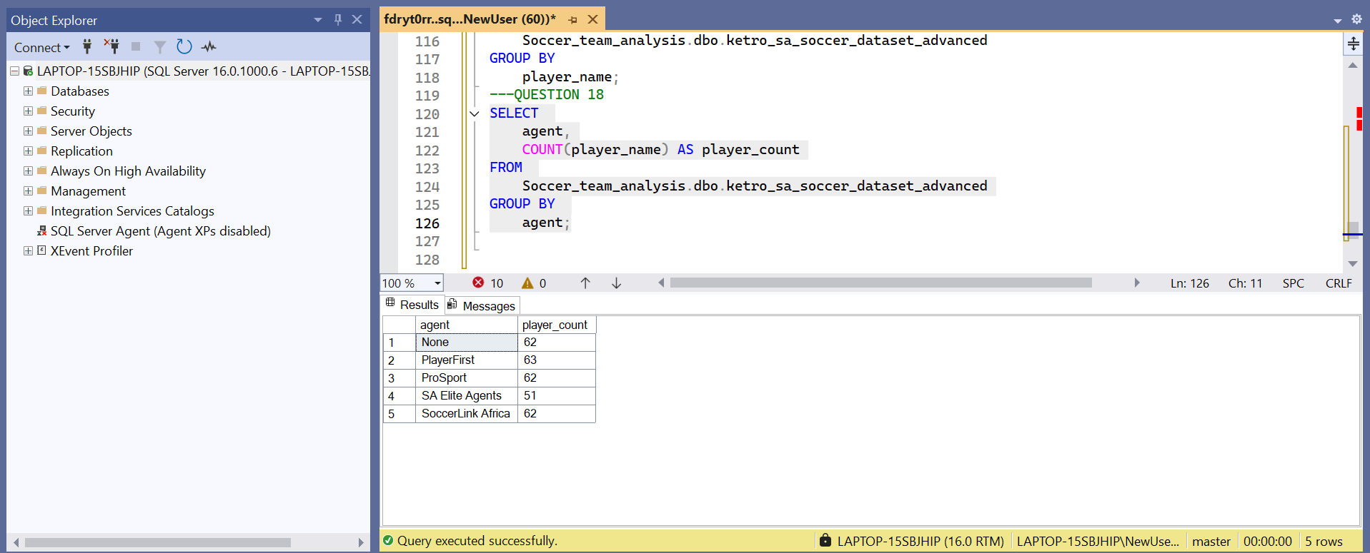
Question 19
Calculate average height and weight by player position.
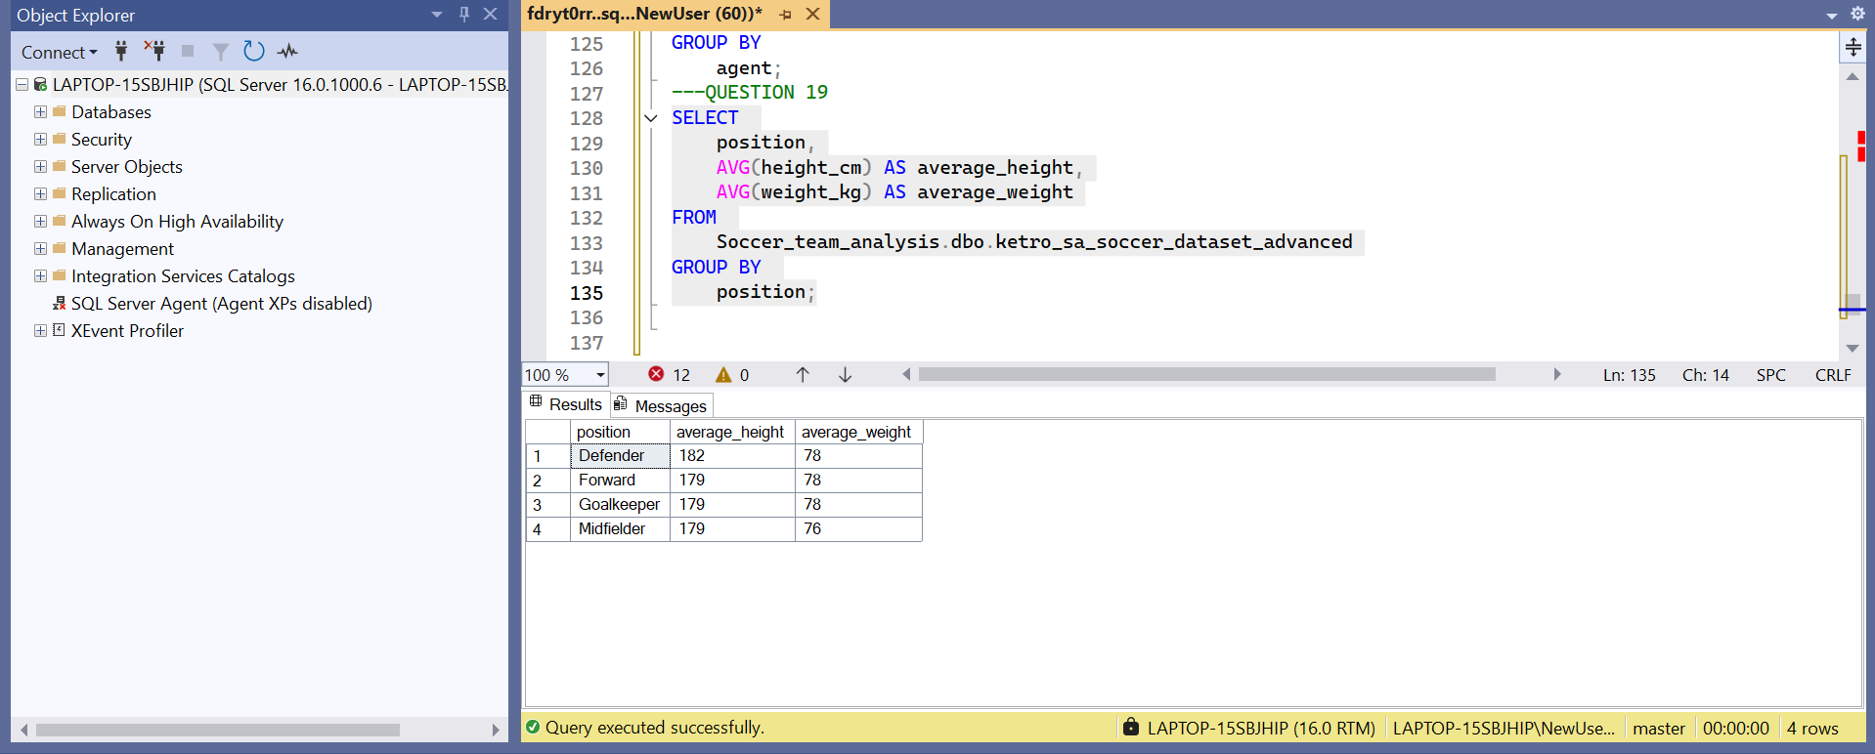
Question 20
Identify players with the highest combined goals and assists
